Supporting Information
When Does Regime Information Improve Volatility Forecasting? Evidence from TGARCH-X, Transformer, and Combined Models
This Supporting Information file reports the empirical diagnostics, robustness analyses, and reproducibility evidence supporting the main manuscript. Appendix A of the main manuscript separately documents the zero-neutral Student-t HMM emission treatment, pre-specified acceptance and zero-return validity criteria, and real-time information timeline. Those methodological rules are therefore not duplicated here. The primary empirical sample contains 52 firms in 11 sectors from 1 August 2016 to 31 July 2026. The untouched FinalTest period contains 801 dates and 8,415 sector-day observations. The study retains machine-readable data, code, and outputs for all reported analyses in reproducibility bundles for R and Python, enabling independent reproduction of the analyses and results.
Table S1. Evidence Location Crosswalk
Evidence area | Location | Purpose
Zero-neutral HMM implementation rules | Main manuscript, Appendix A | Emission treatment, acceptance criteria, zero-return validity rules, and leakage-safe real-time filtering timeline.
Forecast coverage and imputation | Supporting Information, Tables S2-S3 | Usable forecasts, coverage, and leakage-safe TGARCH-X imputation.
Neural tuning and seed stability | Supporting Information, Table S4 | Selected hyperparameters, epochs, parameter counts, and five-seed stability.
Regime validity | Supporting Information, Tables S5-S8 | Estimated HMM parameters, empirical zero-return diagnostics, validity outcomes, and filtered probability summaries.
Regime transmission | Supporting Information, Tables S9-S10 | TGARCH-X calibration factors and dynamic combination parameters.
Sector heterogeneity | Supporting Information, Tables S11-S12; Figure S4 | Sector-level QLIKE across benchmarks and focal models.
Predictive-accuracy inference | Supporting Information, Tables S13-S15 | DM-HLN-Holm, bootstrap CIs, MCS/SPA, and conditional tests.
Moderation robustness | Supporting Information, Table S16 | Multiplicity-adjusted clustered and wild-cluster interaction inference.
Target and state robustness | Supporting Information, Tables S17-S20 | Weighting, Parkinson, three-state, sequence, and split sensitivity.
TGARCH-X sensitivity | Supporting Information, Table S21 | Window, distribution, and X-variable robustness.
Residual and economic diagnostics | Supporting Information, Tables S22-S23 | Residual checks and volatility-targeting diagnostics.
Time-varying loss differences | Supporting Information, Figures S1-S3 | Rolling relative QLIKE for the three matched focal pairs.
Note. Appendix A contains the methodological HMM rules. This Supporting Information file includes empirical diagnostics, robustness analyses, figures, and reproducibility evidence supporting the main-text results.

S1. Forecast Coverage, Missingness, and Reproducibility
Table S2. FinalTest Forecast Coverage
Model | Available | Total | Coverage | Dates | Sectors
EWMA | 8415 | 8415 | 100% | 801 | 11
Historical variance | 8415 | 8415 | 100% | 801 | 11
TGARCH-X | 8415 | 8415 | 100% | 801 | 11
TGARCH | 8415 | 8415 | 100% | 801 | 11
GJR-GARCH | 8410 | 8415 | 99.941% | 801 | 11
GARCH | 8415 | 8415 | 100% | 801 | 11
GRU | 8415 | 8415 | 100% | 801 | 11
Transformer | 8415 | 8415 | 100% | 801 | 11
PatchTST | 8415 | 8415 | 100% | 801 | 11
Note. All primary models except GJR-GARCH have complete FinalTest coverage. GJR-GARCH is missing five of 8,415 sector-days.

Table S3. Primary TGARCH-X Exogenous-Regressor Imputation Audit
Sector | Origins | Windows with any imputation | Mean training X imputation | Forecast origins imputed | Origin imputation rate
Agriculture | 2202 | 17.80% | 7.15% | 159 | 7.22%
Automobiles and Accessories | 732 | 47.40% | 9.29% | 68 | 9.29%
Banking | 2287 | 0.09% | 0.00% | 0 | 0.00%
Commercial and Services | 2287 | 10.06% | 0.18% | 4 | 0.17%
Construction and Allied | 1452 | 23.83% | 5.92% | 86 | 5.92%
Energy and Petroleum | 2287 | 16.18% | 2.40% | 55 | 2.40%
Insurance | 2287 | 0.09% | 0.00% | 0 | 0.00%
Investment | 2287 | 14.08% | 1.66% | 38 | 1.66%
Investment Services | 2263 | 0.09% | 0.00% | 0 | 0.00%
Manufacturing and Allied | 2287 | 15.13% | 4.46% | 102 | 4.46%
Telecommunication and Technology | 2287 | 0.09% | 0.00% | 0 | 0.00%
Note. Imputation uses only the contemporaneous rolling training-window median; future observations never enter imputation or scaling.

S2. Neural Hyperparameters and Seed Stability
Table S4. Selected Neural Configuration and Five-Seed Stability by Sector
Model | Sector | HP | Epoch | Parameters | Validation QLIKE | FinalTest seed mean | Seed SD | Seeds
GRU | Agriculture | 1 | 6 | 5697 | 2.5380 | 3.6263 | 0.2787 | 5
GRU | Automobiles and Accessories | 1 | 30 | 5697 | 2.6851 | 7.2414 | 0.2977 | 5
GRU | Banking | 1 | 4 | 5697 | 1.6664 | 5.3038 | 0.2027 | 5
GRU | Commercial and Services | 2 | 5 | 10817 | 1.2578 | 2.1325 | 0.2197 | 5
GRU | Construction and Allied | 1 | 6 | 5697 | 4.5826 | 5.2967 | 0.2905 | 5
GRU | Energy and Petroleum | 2 | 15 | 10817 | 1.9859 | 4.8674 | 0.0878 | 5
GRU | Insurance | 2 | 17 | 10817 | 1.7055 | 2.2284 | 0.4912 | 5
GRU | Investment | 1 | 4 | 5697 | 2.3455 | 4.7987 | 0.1898 | 5
GRU | Investment Services | 1 | 18 | 5697 | 2.3034 | 2.5646 | 0.0248 | 5
GRU | Manufacturing and Allied | 1 | 4 | 5697 | 2.1727 | 4.4330 | 0.5744 | 5
GRU | Telecommunication and Technology | 1 | 4 | 5697 | 2.1430 | 5.6318 | 0.2488 | 5
PatchTST | Agriculture | 2 | 2 | 21649 | 2.5556 | 2.9356 | 0.0477 | 5
PatchTST | Automobiles and Accessories | 1 | 15 | 9825 | 2.7592 | 4.0937 | 0.0330 | 5
PatchTST | Banking | 2 | 3 | 21649 | 1.6506 | 1.8792 | 0.0976 | 5
PatchTST | Commercial and Services | 2 | 7 | 21649 | 1.2910 | 1.7133 | 0.0055 | 5
PatchTST | Construction and Allied | 2 | 3 | 21649 | 4.5539 | 2.9945 | 0.0863 | 5
PatchTST | Energy and Petroleum | 2 | 38 | 21649 | 1.9279 | 1.9585 | 0.0286 | 5
PatchTST | Insurance | 1 | 5 | 9825 | 1.6946 | 1.6506 | 0.0100 | 5
PatchTST | Investment | 2 | 20 | 21649 | 2.2643 | 2.2137 | 0.0351 | 5
PatchTST | Investment Services | 1 | 3 | 9825 | 2.4148 | 2.5393 | 0.0076 | 5
PatchTST | Manufacturing and Allied | 2 | 3 | 21649 | 2.1013 | 2.5159 | 0.0795 | 5
PatchTST | Telecommunication and Technology | 1 | 19 | 9825 | 2.1519 | 2.8456 | 0.0952 | 5
Transformer | Agriculture | 2 | 2 | 22081 | 2.5583 | 3.3448 | 0.3029 | 5
Transformer | Automobiles and Accessories | 2 | 9 | 22081 | 2.7821 | 5.8565 | 0.5924 | 5
Transformer | Banking | 2 | 3 | 22081 | 1.6045 | 4.0227 | 0.6352 | 5
Transformer | Commercial and Services | 2 | 5 | 22081 | 1.3233 | 1.7168 | 0.0114 | 5
Transformer | Construction and Allied | 2 | 3 | 22081 | 4.6914 | 4.2447 | 0.5589 | 5
Transformer | Energy and Petroleum | 2 | 20 | 22081 | 1.9478 | 3.7482 | 0.4851 | 5
Transformer | Insurance | 1 | 15 | 10113 | 1.6872 | 1.7372 | 0.0832 | 5
Transformer | Investment | 1 | 3 | 10113 | 2.2734 | 2.9047 | 0.6853 | 5
Transformer | Investment Services | 2 | 20 | 22081 | 2.3802 | 2.6867 | 0.1278 | 5
Transformer | Manufacturing and Allied | 2 | 3 | 22081 | 2.0999 | 3.1333 | 0.3841 | 5
Transformer | Telecommunication and Technology | 1 | 11 | 10113 | 2.1492 | 3.2155 | 0.5314 | 5
Note. Selection uses chronological Validation QLIKE. Final forecasts average seeds 11, 23, 42, 71, and 101.

S3. Regime Estimation and Validity Diagnostics
Appendix A defines the primary HMM acceptance and zero-return validity rules. Tables S5-S8 report the corresponding empirical estimates, diagnostics, sector-level validity outcomes, and filtered probabilities.

Table S5. Primary Zero-Neutral Student-t HMM Final-Fit Parameters
Sector | N | Zero share | pLL | pHH | σ low | σ high | ν | Low-state share | Variance ratio H/L | Rare-state warning
Agriculture | 1327 | 6.93% | 0.714 | 0.850 | 0.372 | 1.056 | 9.40 | 31.57% | 16.88 | No
Automobiles and Accessories | 214 | 28.50% | 0.716 | 0.968 | 0.209 | 1.044 | 2983.01 | 4.67% | 36.84 | Yes
Banking | 1388 | 0.00% | 0.962 | 0.892 | 0.454 | 1.265 | 5.25 | 79.11% | 12.37 | No
Commercial and Services | 1388 | 0.00% | 0.915 | 0.889 | 0.502 | 1.200 | 10.13 | 60.88% | 8.50 | No
Construction and Allied | 774 | 34.88% | 0.833 | 0.957 | 0.221 | 0.918 | 8.53 | 14.21% | 28.63 | No
Energy and Petroleum | 1388 | 0.94% | 0.936 | 0.861 | 0.621 | 1.413 | 18.54 | 75.00% | 7.54 | No
Insurance | 1388 | 0.14% | 0.910 | 0.776 | 0.573 | 1.483 | 14.80 | 79.97% | 10.50 | No
Investment | 1388 | 4.03% | 0.892 | 0.879 | 0.356 | 1.105 | 5.45 | 56.84% | 15.04 | No
Investment Services | 1386 | 13.85% | 0.897 | 0.907 | 0.478 | 1.267 | 96.97 | 49.78% | 9.89 | No
Manufacturing and Allied | 1388 | 0.58% | 0.863 | 0.808 | 0.407 | 1.167 | 5.32 | 64.70% | 14.57 | No
Telecommunication and Technology | 1388 | 18.01% | 0.970 | 0.974 | 0.528 | 1.057 | 6.61 | 44.31% | 4.37 | No
Note. The final HMM is fitted through Validation_End and filters StackTrain and FinalTest forward.

Table S6. Primary Zero-Return Regime-Validity Audit
Sector | Zero share | Low-state share | P(Low|Zero) | P(Zero|Low) | Phi | Variance ratio H/L | Rare-state warning | Validity
Agriculture | 6.93% | 31.57% | 0.141 | 0.031 | -0.102 | 16.88 | No | Pass
Automobiles and Accessories | 28.50% | 4.67% | 0.000 | 0.000 | -0.140 | 36.84 | Yes | Pass
Banking | 0.00% | 79.11% | — | 0.000 | — | 12.37 | No | Pass
Commercial and Services | 0.00% | 60.88% | — | 0.000 | — | 8.50 | No | Pass
Construction and Allied | 34.88% | 14.21% | 0.111 | 0.273 | -0.065 | 28.63 | No | Pass
Energy and Petroleum | 0.94% | 75.00% | 0.846 | 0.011 | 0.022 | 7.54 | No | Pass
Insurance | 0.14% | 79.97% | 1.000 | 0.002 | 0.019 | 10.50 | No | Pass
Investment | 4.03% | 56.84% | 0.786 | 0.056 | 0.090 | 15.04 | No | Pass
Investment Services | 13.85% | 49.78% | 0.630 | 0.175 | 0.106 | 9.89 | No | Pass
Manufacturing and Allied | 0.58% | 64.70% | 1.000 | 0.009 | 0.056 | 14.57 | No | Pass
Telecommunication and Technology | 18.01% | 44.31% | 0.340 | 0.138 | -0.097 | 4.37 | No | Pass
Note. All 11 sectors pass the pre-specified validity rule; Automobiles and Accessories receives only a rare-state warning.

Table S7. Zero-Return Association under Conventional Student-t and Primary Zero-Neutral HMMs
Sector | Conventional P(Low|Zero) | Conventional P(Zero|Low) | Conventional phi | Primary P(Low|Zero) | Primary P(Zero|Low) | Primary phi
Agriculture | 0.685 | 0.181 | 0.261 | 0.141 | 0.031 | -0.102
Automobiles and Accessories | 1.000 | 0.726 | 0.786 | 0.000 | 0.000 | -0.140
Banking | — | 0.000 | — | — | 0.000 | —
Commercial and Services | — | 0.000 | — | — | 0.000 | —
Construction and Allied | 1.000 | 0.831 | 0.860 | 0.111 | 0.273 | -0.065
Energy and Petroleum | 1.000 | 0.013 | 0.057 | 0.846 | 0.011 | 0.022
Insurance | 1.000 | 0.002 | 0.019 | 1.000 | 0.002 | 0.019
Investment | 0.911 | 0.068 | 0.152 | 0.786 | 0.056 | 0.090
Investment Services | 0.844 | 0.240 | 0.287 | 0.630 | 0.175 | 0.106
Manufacturing and Allied | 1.000 | 0.009 | 0.057 | 1.000 | 0.009 | 0.056
Telecommunication and Technology | 1.000 | 0.868 | 0.916 | 0.340 | 0.138 | -0.097
Note. The conventional Student-t specification is diagnostic only and shows how exact zeros can dominate continuous-emission state classification.

Table S8. Filtered High-Volatility Probability Summary
Sector | N | Mean | SD | P10 | Median | P90 | Share <0.10 | Share >0.90
Agriculture | 2402 | 0.609 | 0.268 | 0.239 | 0.604 | 0.986 | 0.0% | 21.6%
Automobiles and Accessories | 932 | 0.844 | 0.224 | 0.457 | 0.946 | 1.000 | 0.0% | 60.8%
Banking | 2487 | 0.254 | 0.294 | 0.028 | 0.101 | 0.782 | 49.9% | 6.4%
Commercial and Services | 2487 | 0.427 | 0.308 | 0.087 | 0.343 | 0.915 | 14.1% | 11.2%
Construction and Allied | 1652 | 0.778 | 0.261 | 0.330 | 0.882 | 1.000 | 1.8% | 46.2%
Energy and Petroleum | 2487 | 0.296 | 0.294 | 0.057 | 0.150 | 0.832 | 36.7% | 7.8%
Insurance | 2487 | 0.326 | 0.290 | 0.067 | 0.196 | 0.852 | 27.4% | 8.4%
Investment | 2487 | 0.520 | 0.332 | 0.094 | 0.493 | 0.982 | 11.4% | 21.2%
Investment Services | 2463 | 0.546 | 0.320 | 0.129 | 0.540 | 0.994 | 4.2% | 20.4%
Manufacturing and Allied | 2487 | 0.453 | 0.304 | 0.108 | 0.382 | 0.942 | 7.5% | 13.8%
Telecommunication and Technology | 2487 | 0.566 | 0.334 | 0.087 | 0.645 | 0.964 | 11.5% | 22.4%
Note. The regime-informed models use filtered probabilities generated forward in real time.

S4. Regime Calibration and Forecast-Combination Parameters
Table S9. TGARCH-X Probability-Weighted Calibration Factors
Sector | StackTrain N | Unconditional | Raw low | Raw high | Shrunk low | Shrunk high
Agriculture | 281 | 0.753 | 0.876 | 0.689 | 0.850 | 0.697
Automobiles and Accessories | 188 | 0.573 | 0.789 | 0.546 | 0.671 | 0.550
Banking | 298 | 1.086 | 1.111 | 1.004 | 1.108 | 1.026
Commercial and Services | 298 | 1.099 | 1.163 | 1.040 | 1.153 | 1.048
Construction and Allied | 191 | 0.480 | 0.645 | 0.424 | 0.588 | 0.432
Energy and Petroleum | 298 | 0.932 | 0.874 | 1.170 | 0.880 | 1.098
Insurance | 298 | 1.129 | 1.166 | 1.048 | 1.162 | 1.065
Investment | 298 | 0.983 | 1.240 | 0.786 | 1.199 | 0.811
Investment Services | 280 | 0.887 | 1.039 | 0.776 | 1.013 | 0.791
Manufacturing and Allied | 298 | 1.201 | 1.230 | 1.155 | 1.227 | 1.163
Telecommunication and Technology | 298 | 0.978 | 0.999 | 0.969 | 0.994 | 0.970
Note. State-specific factors are estimated on StackTrain only, shrunk toward the unconditional factor, and interpolated using filtered P(High).

Table S10. Probability-Dependent Combination Parameters and Boundary Audit
Sector | Intercept a | Slope b | Mean Transformer weight | Min weight | Max weight | CV QLIKE | Any bound hit
Agriculture | 1.943 | -2.990 | 0.493 | 0.260 | 0.796 | 3.325 | No
Automobiles and Accessories | 8.000 | -8.922 | 0.464 | 0.285 | 0.999 | 4.051 | Yes
Banking | -1.150 | 0.071 | 0.244 | 0.241 | 0.254 | 1.832 | No
Commercial and Services | 3.013 | -4.597 | 0.608 | 0.172 | 0.937 | 1.292 | No
Construction and Allied | 7.787 | -7.037 | 0.835 | 0.679 | 0.999 | 3.639 | No
Energy and Petroleum | -0.871 | 1.963 | 0.382 | 0.316 | 0.748 | 1.791 | No
Insurance | -3.838 | 12.000 | 0.409 | 0.039 | 1.000 | 1.605 | Yes
Investment | 8.000 | -8.052 | 0.849 | 0.488 | 0.999 | 2.527 | Yes
Investment Services | 8.000 | -7.995 | 0.856 | 0.501 | 0.999 | 2.671 | Yes
Manufacturing and Allied | -8.000 | -12.000 | 0.000 | 0.000 | 0.000 | 2.346 | Yes
Telecommunication and Technology | -1.856 | 1.509 | 0.318 | 0.143 | 0.414 | 2.170 | No
Note. Five sectors reach at least one configured parameter bound, supporting treatment of the dynamic combination as secondary robustness evidence.

S5. Sector-Level Forecast Accuracy
Table S11. Sector-Level QLIKE for Benchmark Models
Sector | Historical Variance | EWMA | GARCH | GJR-GARCH | TGARCH | GRU | PatchTST
Agriculture | 2.344 | 2.305 | 2.662 | 2.617 | 2.649 | 3.964 | 2.697
Automobiles and Accessories | 3.821 | 3.821 | 4.185 | 4.053 | 4.328 | 8.403 | 4.020
Banking | 1.696 | 1.638 | 1.679 | 1.763 | 1.639 | 6.498 | 1.888
Commercial and Services | 1.917 | 1.845 | 1.657 | 1.661 | 1.638 | 2.486 | 1.868
Construction and Allied | 2.461 | 2.377 | 2.428 | 2.476 | 2.968 | 5.887 | 2.702
Energy and Petroleum | 2.091 | 1.928 | 1.899 | 1.902 | 1.877 | 5.967 | 2.036
Insurance | 1.642 | 1.622 | 1.591 | 1.593 | 1.593 | 2.980 | 1.619
Investment | 1.974 | 1.958 | 2.169 | 2.029 | 2.175 | 5.728 | 2.167
Investment Services | 2.501 | 2.521 | 2.551 | 2.632 | 2.526 | 2.519 | 2.486
Manufacturing and Allied | 2.256 | 2.287 | 2.333 | 2.415 | 2.320 | 5.671 | 2.487
Telecommunication and Technology | 2.608 | 2.542 | 2.557 | 2.556 | 2.634 | 6.969 | 2.986
Note. Lower QLIKE indicates better forecast accuracy.

Table S12. Sector-Level QLIKE for Matched Focal Models
Sector | Baseline TGARCH-X | Regime-Calibrated TGARCH-X | Baseline Transformer | Regime-Aware Transformer | Static Combined Forecast | Regime-Aware Combined Forecast
Agriculture | 2.618 | 2.516 | 3.285 | 3.274 | 3.056 | 3.068
Automobiles and Accessories | 4.261 | 4.078 | 6.433 | 6.416 | 6.170 | 5.976
Banking | 1.654 | 1.649 | 5.229 | 5.252 | 4.535 | 4.548
Commercial and Services | 1.638 | 1.645 | 1.870 | 1.857 | 1.694 | 1.744
Construction and Allied | 3.034 | 3.420 | 4.474 | 4.425 | 4.235 | 4.198
Energy and Petroleum | 1.885 | 1.885 | 4.764 | 4.039 | 4.391 | 3.573
Insurance | 1.632 | 1.637 | 1.758 | 1.870 | 1.642 | 1.721
Investment | 2.389 | 2.322 | 3.797 | 3.821 | 3.705 | 3.703
Investment Services | 2.528 | 2.515 | 2.601 | 2.582 | 2.449 | 2.434
Manufacturing and Allied | 2.458 | 2.465 | 3.717 | 3.377 | 2.458 | 2.465
Telecommunication and Technology | 2.595 | 2.592 | 3.997 | 4.810 | 3.412 | 4.062
Note. Matched pairs isolate the incremental value of regime information within the three focal channels.

S6. Predictive-Accuracy Inference
Table S13. Matched QLIKE Comparisons with HAC-HLN Inference and Block-Bootstrap Confidence Intervals
State | Regime-informed model | Baseline | Mean Δ QLIKE | HLN statistic | p | Holm p | 95% bootstrap CI
All | Regime-Aware Combined Forecast | Static Combined Forecast | 0.2356 | 10.070 | <0.001 | <0.001 | [0.1833, 0.2913]
All | Regime-Aware Transformer | Baseline Transformer | 0.2734 | 6.789 | <0.001 | <0.001 | [0.1867, 0.3632]
All | Regime-Calibrated TGARCH-X | Baseline TGARCH-X | -0.0009 | -0.154 | 0.878 | 0.878 | [-0.0132, 0.0085]
High | Regime-Aware Combined Forecast | Static Combined Forecast | 0.2653 | 6.043 | <0.001 | <0.001 | [0.1718, 0.3677]
High | Regime-Aware Transformer | Baseline Transformer | 0.1390 | 2.261 | 0.024 | 0.048 | [0.0120, 0.2776]
High | Regime-Calibrated TGARCH-X | Baseline TGARCH-X | -0.0104 | -1.423 | 0.155 | 0.155 | [-0.0248, 0.0042]
Low | Regime-Aware Combined Forecast | Static Combined Forecast | 0.0663 | 2.734 | 0.006 | 0.013 | [0.0116, 0.1177]
Low | Regime-Aware Transformer | Baseline Transformer | 0.1529 | 3.785 | <0.001 | <0.001 | [0.0624, 0.2391]
Low | Regime-Calibrated TGARCH-X | Baseline TGARCH-X | -0.0016 | -0.242 | 0.809 | 0.809 | [-0.0151, 0.0109]
Note. Δ QLIKE equals regime-informed loss minus baseline loss. Negative values favor regime information. Bootstrap intervals use 5,000 moving-block replications.

Table S14. 90% Model Confidence Set for the Six Focal Models
State | Model | MCS status | Dates | Replications
All | Baseline TGARCH-X | Included | 801 | 5000
All | Baseline Transformer | Excluded | 801 | 5000
All | Regime-Aware Combined Forecast | Excluded | 801 | 5000
All | Regime-Aware Transformer | Excluded | 801 | 5000
All | Regime-Calibrated TGARCH-X | Included | 801 | 5000
All | Static Combined Forecast | Excluded | 801 | 5000
Low | Baseline TGARCH-X | Included | 800 | 5000
Low | Baseline Transformer | Excluded | 800 | 5000
Low | Regime-Aware Combined Forecast | Excluded | 800 | 5000
Low | Regime-Aware Transformer | Excluded | 800 | 5000
Low | Regime-Calibrated TGARCH-X | Included | 800 | 5000
Low | Static Combined Forecast | Excluded | 800 | 5000
High | Baseline TGARCH-X | Included | 800 | 5000
High | Baseline Transformer | Excluded | 800 | 5000
High | Regime-Aware Combined Forecast | Excluded | 800 | 5000
High | Regime-Aware Transformer | Excluded | 800 | 5000
High | Regime-Calibrated TGARCH-X | Included | 800 | 5000
High | Static Combined Forecast | Excluded | 800 | 5000
Note. Each state-specific MCS retains both the baseline TGARCH-X and the regime-calibrated TGARCH-X.

Table S15. Conditional Predictive Ability, Forecast Instability, and SPA Evidence
Comparison/benchmark | Comparator/state | GW statistic | GW or SPA p | GR max |stat| | GR unstable at 5%
Regime-Calibrated TGARCH-X | Baseline TGARCH-X | 5.907 | 0.116 | 2.168 | No
Regime-Aware Transformer | Baseline Transformer | 243.974 | <0.001 | 46.580 | Yes
Regime-Aware Combined Forecast | Static Combined Forecast | 1545.261 | <0.001 | 20.312 | Yes
SPA benchmark: Regime-Calibrated TGARCH-X | All | — | 0.581 | — | —
SPA benchmark: Regime-Calibrated TGARCH-X | Low | — | 0.613 | — | —
SPA benchmark: Regime-Calibrated TGARCH-X | High | — | 0.916 | — | —
Note. SPA values are the consistent p-values from 5,000 stationary-bootstrap replications.

S7. Moderation and Multiple-Testing Robustness
Table S16. Model-by-Regime Interaction Inference with Family-Wise Adjustment
Model | Interaction | Two-way p | Holm two-way p | Webb p | Holm Webb p | Date-FE p | Hard-state p
Baseline Transformer | 0.0157 | 0.644 | 1.000 | 0.651 | 1.000 | 0.637 | 0.736
Regime-Aware Combined Forecast | -0.0411 | 0.282 | 1.000 | 0.347 | 1.000 | 0.259 | 0.204
Regime-Aware Transformer | -0.0079 | 0.841 | 1.000 | 0.826 | 1.000 | 0.838 | 0.428
Regime-Calibrated TGARCH-X | -0.0244 | 0.067 | 0.336 | 0.021 | 0.105 | 0.042 | 0.031
Static Combined Forecast | -0.0321 | 0.290 | 1.000 | 0.333 | 1.000 | 0.270 | 0.180
Note. No interaction remains significant under the family-wise Holm correction.

S8. Weighting, Proxy, State, and Sequence Robustness
Table S17. Squared-Return Accuracy under Alternative Cross-Sectional Weighting Schemes
Weighting scheme | Model | QLIKE | RMSE | MAE
CappedMarketCapitalisation | Baseline TGARCH-X | 2.1494 | 0.008111 | 0.000626
CappedMarketCapitalisation | Baseline Transformer | 4.0297 | 0.137898 | 0.059727
CappedMarketCapitalisation | Regime-Aware Combined Forecast | 3.4543 | 0.035505 | 0.015109
CappedMarketCapitalisation | Regime-Aware Transformer | 4.0955 | 0.135455 | 0.057339
CappedMarketCapitalisation | Regime-Calibrated TGARCH-X | 2.1523 | 0.008002 | 0.000614
CappedMarketCapitalisation | Static Combined Forecast | 3.3604 | 0.041883 | 0.017637
EqualSector | Baseline TGARCH-X | 2.3582 | 0.005928 | 0.001323
EqualSector | Baseline Transformer | 3.6533 | 0.100791 | 0.041477
EqualSector | Regime-Aware Combined Forecast | 3.2651 | 0.039043 | 0.016264
EqualSector | Regime-Aware Transformer | 3.6352 | 0.092466 | 0.036009
EqualSector | Regime-Calibrated TGARCH-X | 2.3638 | 0.005163 | 0.000962
EqualSector | Static Combined Forecast | 3.2814 | 0.045782 | 0.020200
MarketCapitalisation | Baseline TGARCH-X | 2.1372 | 0.010071 | 0.000613
MarketCapitalisation | Baseline Transformer | 4.4178 | 0.166517 | 0.078300
MarketCapitalisation | Regime-Aware Combined Forecast | 3.9988 | 0.043831 | 0.022085
MarketCapitalisation | Regime-Aware Transformer | 4.6912 | 0.173429 | 0.087494
MarketCapitalisation | Regime-Calibrated TGARCH-X | 2.1364 | 0.009969 | 0.000607
MarketCapitalisation | Static Combined Forecast | 3.7632 | 0.045016 | 0.021196
Note. Market-capitalization weighting is primary; equal-sector and capped-capitalization schemes assess concentration sensitivity.

Table S18. Parkinson-Proxy Accuracy for the Focal Models
Weighting scheme | Model | QLIKE | RMSE | MAE
CappedMarketCapitalisation | Baseline TGARCH-X | 2.6315 | 0.008495 | 0.000820
CappedMarketCapitalisation | Baseline Transformer | 2.7781 | 0.137706 | 0.059686
CappedMarketCapitalisation | Regime-Aware Combined Forecast | 2.4496 | 0.035414 | 0.015097
CappedMarketCapitalisation | Regime-Aware Transformer | 2.7626 | 0.135318 | 0.057292
CappedMarketCapitalisation | Regime-Calibrated TGARCH-X | 2.4205 | 0.008386 | 0.000796
CappedMarketCapitalisation | Static Combined Forecast | 2.4732 | 0.041730 | 0.017631
EqualSector | Baseline TGARCH-X | 2.9932 | 0.006979 | 0.001559
EqualSector | Baseline Transformer | 2.8284 | 0.100612 | 0.041419
EqualSector | Regime-Aware Combined Forecast | 2.5532 | 0.038971 | 0.016249
EqualSector | Regime-Aware Transformer | 2.7675 | 0.092352 | 0.035953
EqualSector | Regime-Calibrated TGARCH-X | 2.9350 | 0.006285 | 0.001185
EqualSector | Static Combined Forecast | 2.6517 | 0.045649 | 0.020194
MarketCapitalisation | Baseline TGARCH-X | 2.8255 | 0.010178 | 0.000754
MarketCapitalisation | Baseline Transformer | 3.0355 | 0.166321 | 0.078234
MarketCapitalisation | Regime-Aware Combined Forecast | 2.8001 | 0.043659 | 0.022007
MarketCapitalisation | Regime-Aware Transformer | 3.2416 | 0.173244 | 0.087415
MarketCapitalisation | Regime-Calibrated TGARCH-X | 2.5694 | 0.010077 | 0.000741
MarketCapitalisation | Static Combined Forecast | 2.6622 | 0.044830 | 0.021123
Note. The analysis keeps the forecasts fixed and changes only the evaluation proxy.

Table S19. Three-State Zero-Neutral Student-t HMM Robustness
Three-state label | Model | QLIKE | Dates | Sectors
Low | Baseline TGARCH-X | 1.9990 | 753 | 11
Low | Baseline Transformer | 4.2675 | 753 | 11
Low | Static Combined Forecast | 3.7731 | 753 | 11
Low | Regime-Calibrated TGARCH-X | 1.9871 | 753 | 11
Low | Regime-Aware Transformer | 4.3290 | 753 | 11
Low | Regime-Aware Combined Forecast | 3.8135 | 753 | 11
Medium | Baseline TGARCH-X | 2.0403 | 801 | 11
Medium | Baseline Transformer | 3.9286 | 801 | 11
Medium | Static Combined Forecast | 3.3413 | 801 | 11
Medium | Regime-Calibrated TGARCH-X | 2.0502 | 801 | 11
Medium | Regime-Aware Transformer | 4.1429 | 801 | 11
Medium | Regime-Aware Combined Forecast | 3.4749 | 801 | 11
High | Baseline TGARCH-X | 2.3834 | 773 | 11
High | Baseline Transformer | 3.4667 | 773 | 11
High | Static Combined Forecast | 2.8391 | 773 | 11
High | Regime-Calibrated TGARCH-X | 2.3714 | 773 | 11
High | Regime-Aware Transformer | 3.5320 | 773 | 11
High | Regime-Aware Combined Forecast | 3.0485 | 773 | 11
Note. The three-state exercise reclassifies fixed forecasts into Low, Medium, and High states.

Table S20. Transformer Sequence-Length and FinalTest Reclassification Sensitivity
Robustness | Setting | Model | QLIKE | Dates | Re-estimation status
Sequence length | 10 | Baseline Transformer | 4.4757 | 801 | Full neural re-estimation
Sequence length | 20 | Baseline Transformer | 4.4178 | 801 | Full neural re-estimation
Sequence length | 40 | Baseline Transformer | 4.6624 | 801 | Full neural re-estimation
FinalTest reclassification | 0.55 | Baseline TGARCH-X | 2.0567 | 495 | Forecasts/weights fixed
FinalTest reclassification | 0.55 | Baseline Transformer | 5.7185 | 495 | Forecasts/weights fixed
FinalTest reclassification | 0.55 | Static Combined Forecast | 4.7551 | 495 | Forecasts/weights fixed
FinalTest reclassification | 0.55 | Regime-Calibrated TGARCH-X | 2.0535 | 495 | Forecasts/weights fixed
FinalTest reclassification | 0.55 | Regime-Aware Transformer | 6.2209 | 495 | Forecasts/weights fixed
FinalTest reclassification | 0.55 | Regime-Aware Combined Forecast | 5.1273 | 495 | Forecasts/weights fixed
FinalTest reclassification | 0.65 | Baseline TGARCH-X | 2.0299 | 385 | Forecasts/weights fixed
FinalTest reclassification | 0.65 | Baseline Transformer | 6.7021 | 385 | Forecasts/weights fixed
FinalTest reclassification | 0.65 | Static Combined Forecast | 5.4984 | 385 | Forecasts/weights fixed
FinalTest reclassification | 0.65 | Regime-Calibrated TGARCH-X | 2.0261 | 385 | Forecasts/weights fixed
FinalTest reclassification | 0.65 | Regime-Aware Transformer | 7.3473 | 385 | Forecasts/weights fixed
FinalTest reclassification | 0.65 | Regime-Aware Combined Forecast | 5.9730 | 385 | Forecasts/weights fixed
FinalTest reclassification | 0.75 | Baseline TGARCH-X | 2.1283 | 275 | Forecasts/weights fixed
FinalTest reclassification | 0.75 | Baseline Transformer | 6.7966 | 275 | Forecasts/weights fixed
FinalTest reclassification | 0.75 | Static Combined Forecast | 5.6506 | 275 | Forecasts/weights fixed
FinalTest reclassification | 0.75 | Regime-Calibrated TGARCH-X | 2.1178 | 275 | Forecasts/weights fixed
FinalTest reclassification | 0.75 | Regime-Aware Transformer | 7.4705 | 275 | Forecasts/weights fixed
FinalTest reclassification | 0.75 | Regime-Aware Combined Forecast | 6.1257 | 275 | Forecasts/weights fixed
Note. The 10-, 20-, and 40-day sequence comparisons are fully re-estimated. Split-point sensitivity only reclassifies existing forecasts.

S9. TGARCH-X Window, Distribution, and Exogenous-Variable Sensitivity
Table S21. Common-Support TGARCH-X Sensitivity Comparisons
Family | Alternative | QLIKE | Δ vs anchor | Within-family Holm p | Global Holm p | 95% bootstrap CI
DISTRIBUTION | GED innovations | 2.7665 | +0.6293 | <0.001 | <0.001 | [0.4770, 0.7847]
DISTRIBUTION | Gaussian innovations | 2.0785 | -0.0587 | 0.008 | 0.042 | [-0.1005, -0.0152]
WINDOW | 125-observation window | 2.4025 | +0.2653 | 0.187 | 0.373 | [0.0201, 0.7046]
WINDOW | 250-observation window | 2.0731 | -0.0642 | 0.038 | 0.076 | [-0.1233, -0.0162]
X | Sector volume change lag 1 | 2.1371 | -0.0002 | 0.988 | 0.988 | [-0.0195, 0.0195]
X | Turnover change lag 2 | 2.2233 | +0.0861 | 0.166 | 0.250 | [0.0122, 0.2013]
Note. Anchor: 200 observations, Student-t innovations, turnover-change lag 1. All unique sensitivity specifications have 100% valid coverage, and FinalTest common support is 8,415/8,415 sector-days.
S10. Primary TGARCH-X Residual and Economic Diagnostics
Table S22. Last-Window Primary TGARCH-X Residual and Sign-Bias Diagnostics
Sector | LB residual p | LB squared residual p | ARCH-LM p | Sign-bias p | Persistence
Agriculture | 0.481 | 0.999 | 0.996 | 0.455 | 0.539
Automobiles and Accessories | 0.974 | 0.964 | 0.863 | 0.150 | 0.773
Banking | <0.001 | 0.892 | 0.892 | 0.846 | 0.436
Commercial and Services | <0.001 | 0.776 | 0.844 | 0.469 | 0.849
Construction and Allied | 0.405 | 0.105 | 0.094 | 0.376 | 0.260
Energy and Petroleum | <0.001 | 0.894 | 0.881 | 0.766 | 0.848
Insurance | 0.527 | 0.786 | 0.837 | 0.735 | 0.861
Investment | 0.758 | 0.801 | 0.705 | 0.409 | 0.586
Investment Services | 0.985 | 0.859 | 0.841 | 0.810 | 0.698
Manufacturing and Allied | 0.206 | 0.406 | 0.436 | 0.026 | 0.715
Telecommunication and Technology | 0.508 | 1.000 | 1.000 | 0.200 | 0.881
Note. Banking, Commercial and Services, and Energy and Petroleum retain residual autocorrelation; Manufacturing and Allied show sign bias.
Table S23. Illustrative Volatility-Targeting Diagnostic
Model | Realized annualized volatility | Annualized mean return | Illustrative Sharpe | Mean exposure | Exposure cap
Baseline TGARCH-X | 6.77% | 14.40% | 2.128 | 0.554 | 2.0
Baseline Transformer | 5.51% | 4.24% | 0.768 | 0.296 | 2.0
Static Combined Forecast | 4.70% | 4.78% | 1.018 | 0.315 | 2.0
Regime-Calibrated TGARCH-X | 6.64% | 14.00% | 2.110 | 0.538 | 2.0
Regime-Aware Transformer | 4.77% | 4.08% | 0.854 | 0.267 | 2.0
Regime-Aware Combined Forecast | 4.48% | 4.41% | 0.983 | 0.295 | 2.0
Note. The analysis targets 10% annualized volatility and excludes transaction costs, so it serves as an economic-significance diagnostic rather than a trading-strategy backtest.

S11. Diagnostic Figures
Figure S1. Rolling QLIKE Differential: Regime-Calibrated TGARCH-X minus Baseline TGARCH-X
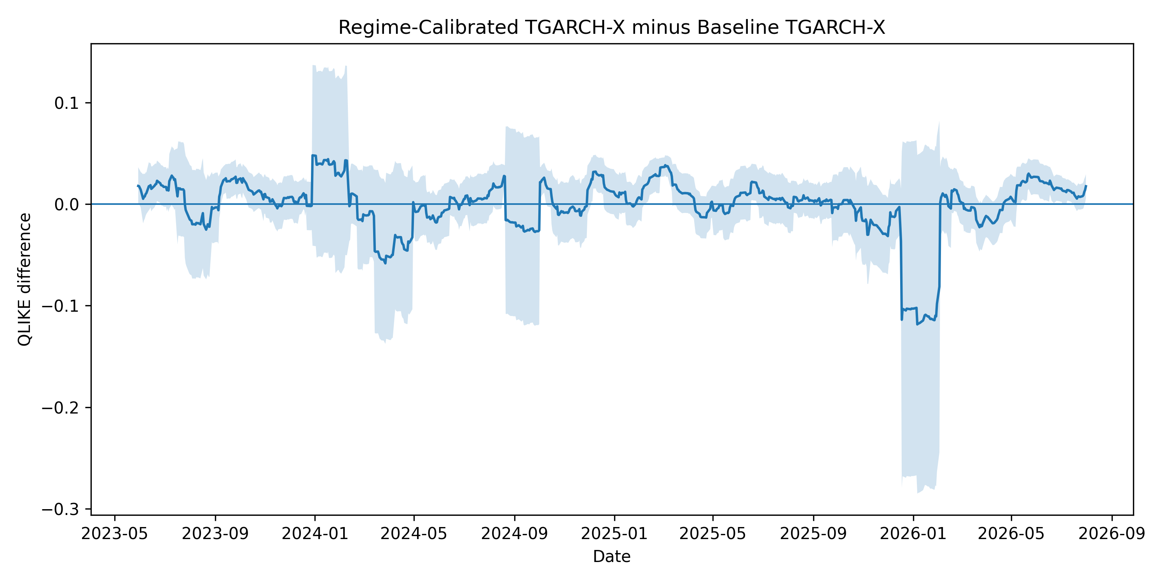
Note. Negative values favor regime calibration.

Figure S2. Rolling QLIKE Differential: Regime-Aware Transformer minus Baseline Transformer
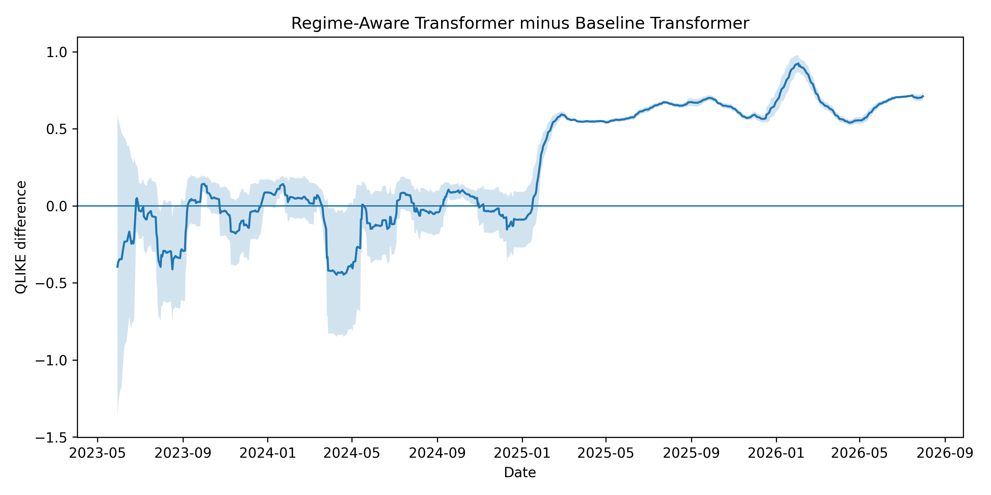
Note. Positive values indicate deterioration from adding the regime-probability input.

Figure S3. Rolling QLIKE Differential: Regime-Aware Combined Forecast minus Static Combined Forecast
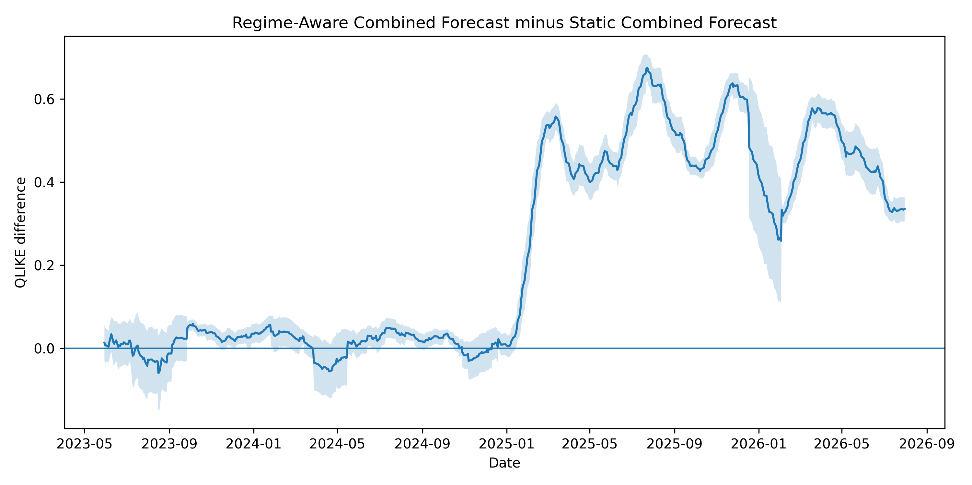
Note. Positive values indicate deterioration from allowing the combination weight to vary with regime probability.

Figure S4. Sector-Level QLIKE Heatmap
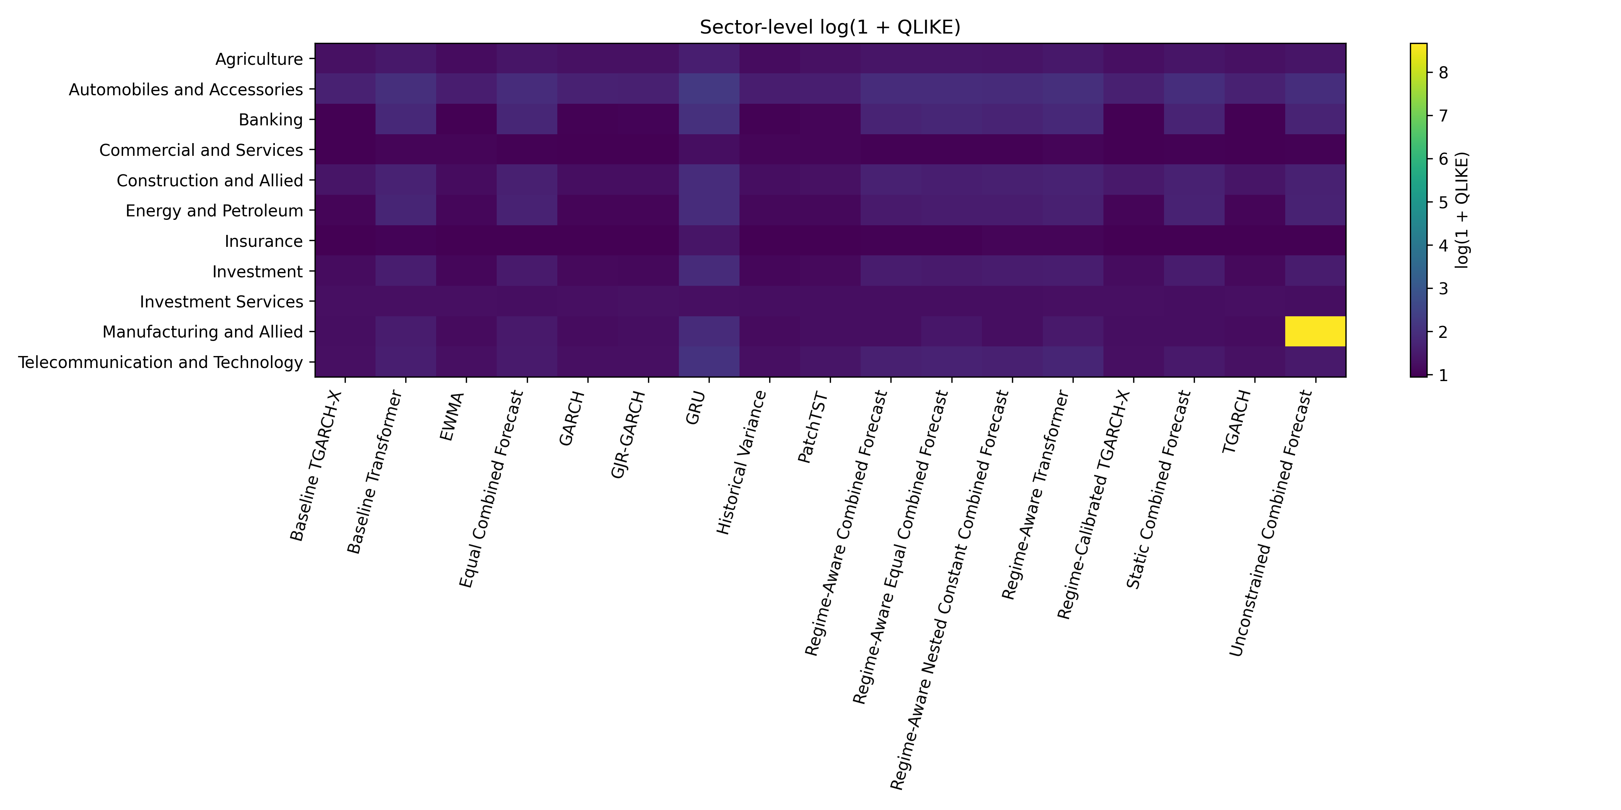
Note. The heatmap displays sector heterogeneity across the evaluated forecasting models.

S12. Reproducibility Note
The completed Python stage was regenerated from scratch in one session without Google Drive or reuse of earlier model checkpoints. The reproducibility bundle stores the exact master data file, the frozen primary R archive, model outputs, figures, environment information, software requirements, run timestamps, SHA256 hashes, and final manifests.
The primary R engine remains frozen. The separate sensitivity suite re-estimates only the TGARCH-X robustness families and does not replace any primary R or Python output. The sensitivity run reports zero fit failures, zero operational fallbacks, 100% valid coverage for each specification, and 100% support for the common FinalTest.

